Laboratory report
LAB#2

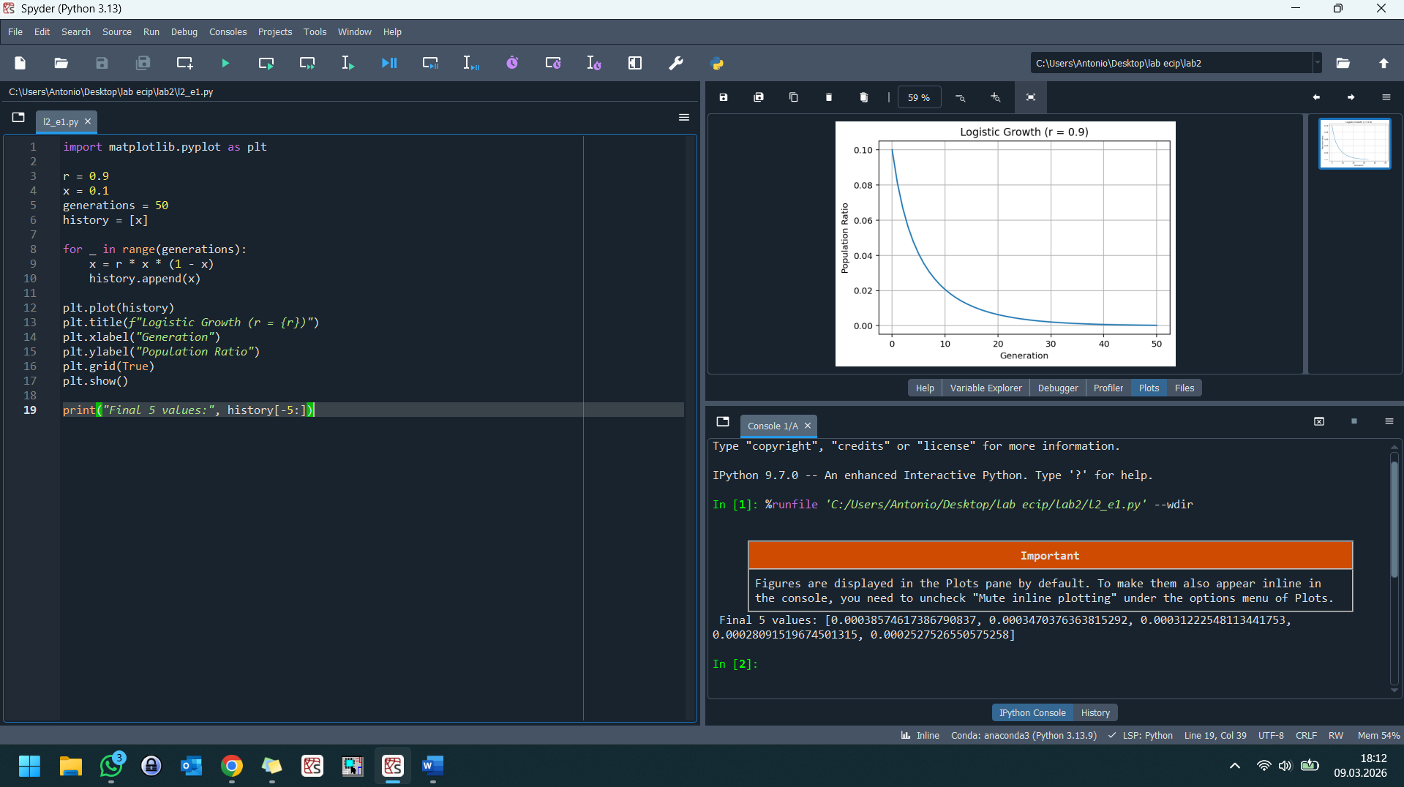
When the growth factor r is set to 0.9, the population faces a predictable and sombre outcome. In the logistic model, the growth rate must be high enough to overcome the natural "friction" of the environment to sustain itself.
Initial Trend: The population begins at 0.1 (10% capacity) and immediately begins to decline.
The Threshold: For a population to persist in this model, r must be greater than 1.0. Because r = 0.9 is less than 1, the "birth rate" is consistently lower than the factors reducing the population. The population will eventually reach extinction. It does not stabilize at a lower number or fluctuate; it asymptotically approaches zero until the population is entirely depleted.

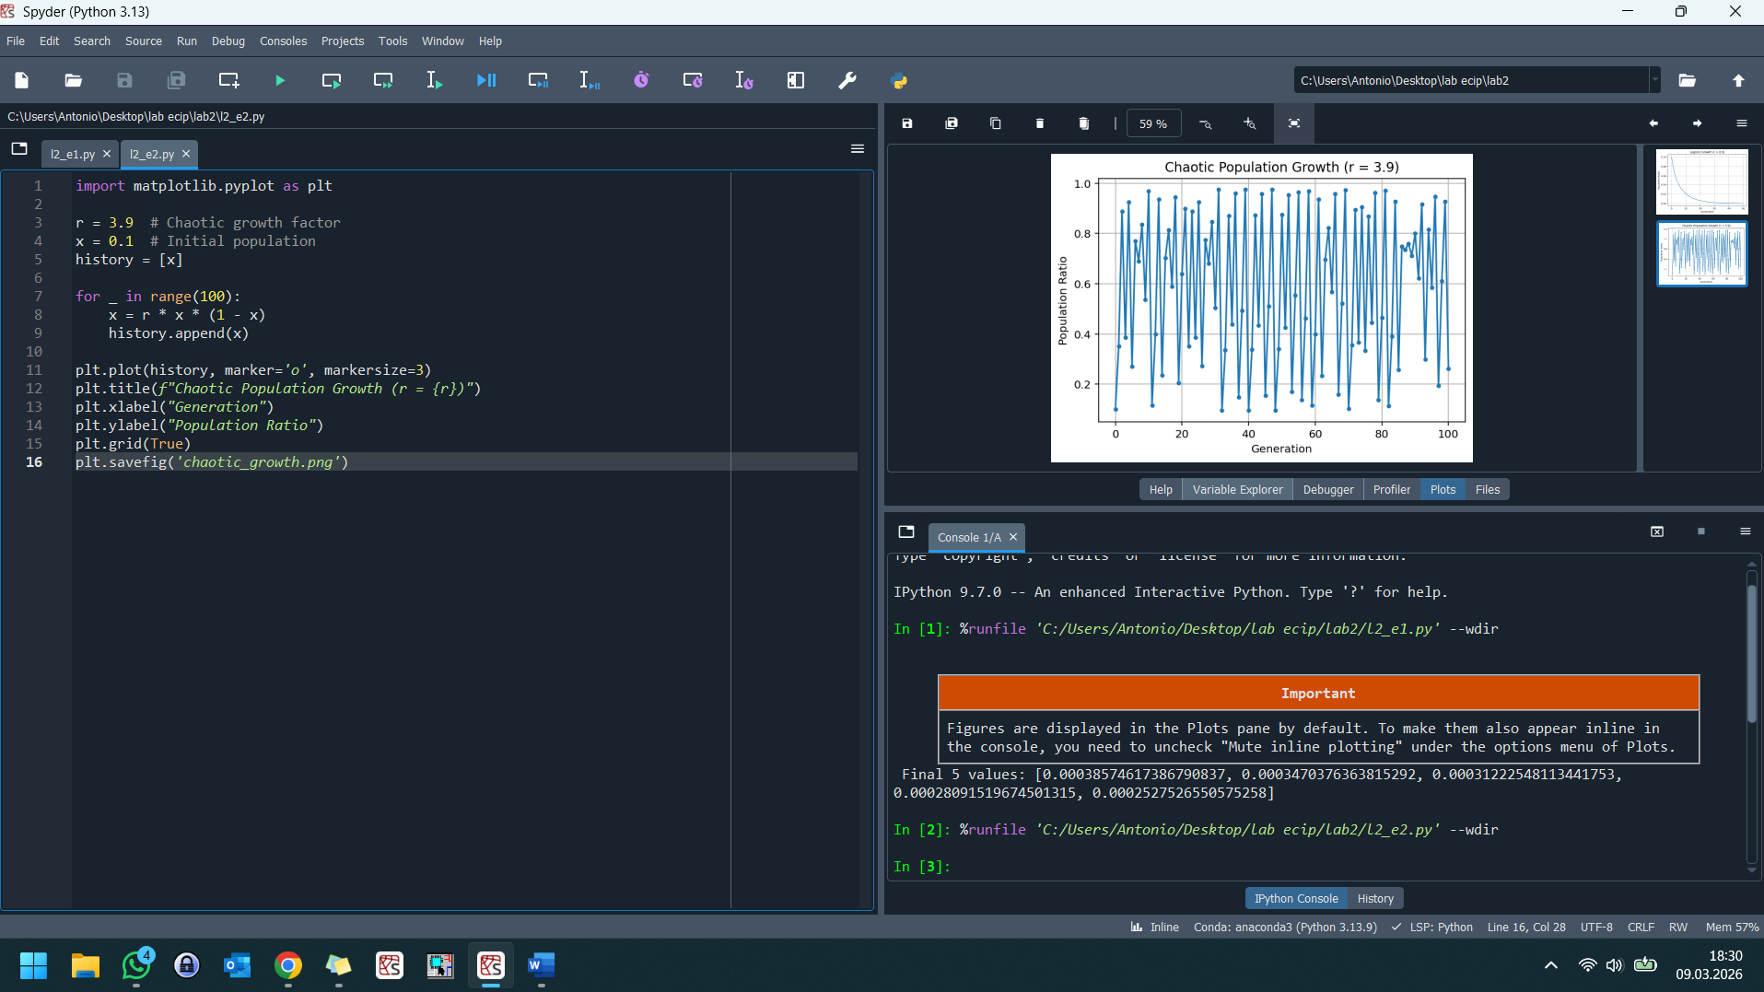
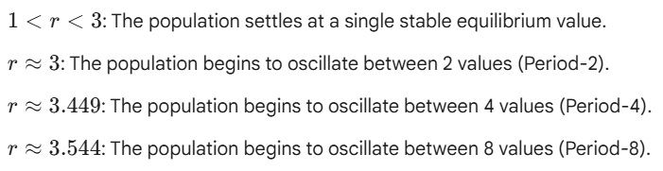
The population growth becomes chaotic at approximately r ~ 3.5699.
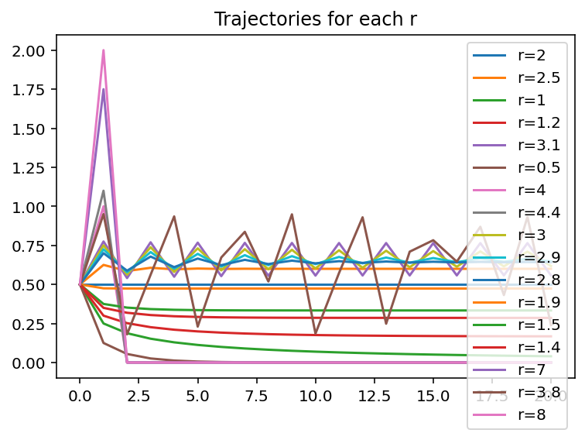
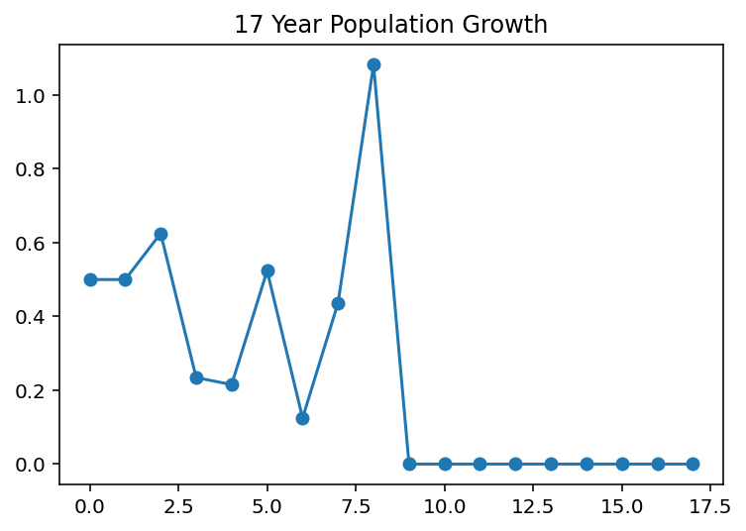
The population growth in the 17th year is 0 (Extinction).
In Year 8, the growth factor spikes to r = 4.4. This causes the population to exceed the stable carrying capacity boundary. In the discrete logistic equation, when r > 4.0, the population is forced beyond 1.0, which mathematically causes the following year's calculation to result in a negative number (or 0). By the time the system reaches the 17th year, even though r continues to change, the population has already "crashed" and cannot recover.
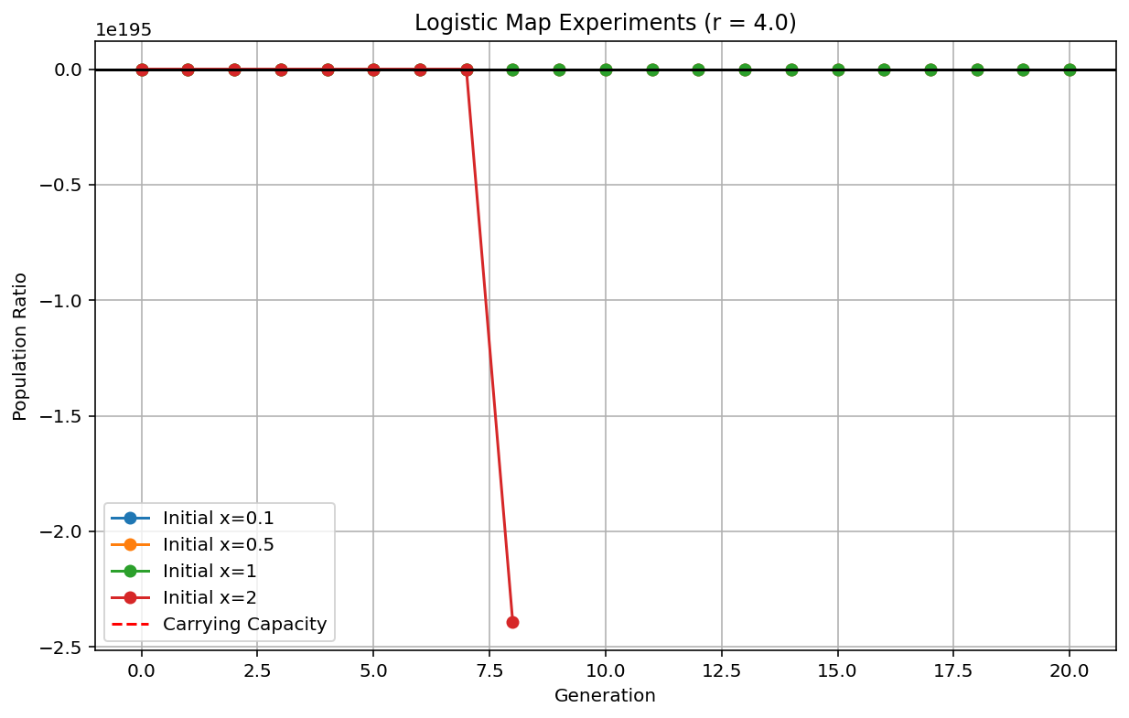
Experiment Report: Observations for r = 4.0
When r=4.0, the system is at the absolute limit of chaotic behavior. Here is how the different starting points affect the population's fate:
1. Initial Population x = 0.1 (Under Capacity)
- Observation: The population exhibits deterministic chaos.
- Fate: It bounces erratically between values very close to 0 and values very close to 1. It never settles into a pattern or a fixed point. This represents a population in a state of constant, unpredictable turbulence.
2. Initial Population x = 0.5 (At Equilibrium Center)
- Observation: The population immediately hits the maximum.
- Fate: Since 4.0 \cdot 0.5 \cdot (1 - 0.5) = 1.0, the population reaches 1.0 in the first generation. However, because the next step involves (1 - 1.0), the population drops to exactly 0 in the second generation and stays there. This is a "perfect crash."
3. Initial Population x = 1.0 (At Carrying Capacity)
- Observation: Immediate collapse.
- Fate: Because the term (1 - x) becomes zero, the population becomes 0 in the very first generation. In biological terms, the environment is so saturated that reproductive success hits zero instantly.
4. Initial Population x = 2.0 (Over Capacity)
- Observation: Mathematical divergence.
- Fate: The population starts outside the viable bounds of the model. Since (1 - 2) = -1, the population becomes negative (-8.0). In a simulation, this represents an instant extinction and a breakdown of the model's logic, as a population cannot be less than zero.
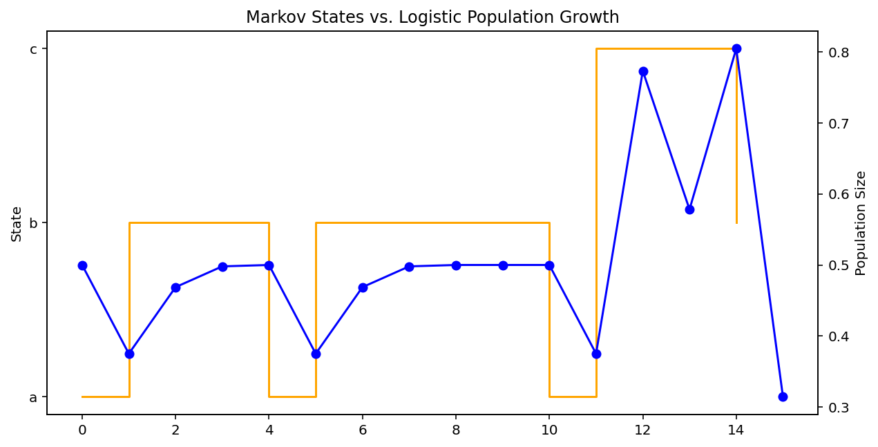
Sequence S: ['a', 'b', 'b', 'b', 'a', 'b', 'b', 'b', 'b', 'b', 'a', 'c', 'c', 'c', 'b']
Growth Factors (r): [1.5, 2, 2, 2, 1.5, 2, 2, 2, 2, 2, 1.5, 3.3, 3.3, 3.3, 2]
Population at step 15: 0.3142110499449078

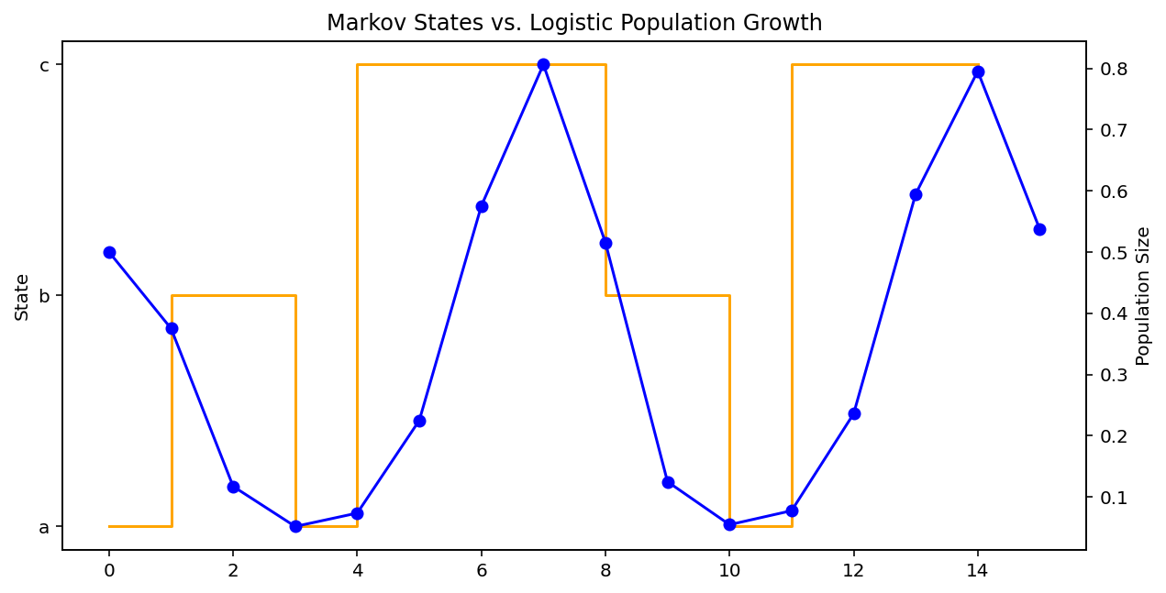
Sequence S: ['a', 'b', 'b', 'a', 'c', 'c', 'c', 'c', 'b', 'b', 'a', 'c', 'c', 'c', 'c']
Growth Factors (r): [1.5, 0.5, 0.5, 1.5, 3.3, 3.3, 3.3, 3.3, 0.5, 0.5, 1.5, 3.3, 3.3, 3.3, 3.3]
Population at step 15: 0.5371608179721296
In most runs, the population survives, but it remains very low. Because state b has a 50% chance of looping into itself (b to b), a "streak" of state b acts as a lethal bottleneck. If the sequence ends with several b states, your population will be near-zero by the 15th step.

